
Elms Court Express
February 2015
Welcome to another edition of the Elms Court Express. Within I hope to provide you all with the latest news and information that's been going on lately.. there certainly has been some changes!! Steve and Jenny
****************************
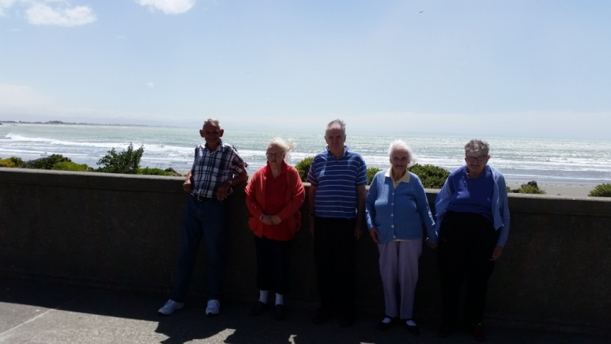
Upcoming outings
Wednesday afternoons are generally the day where Calvin and/or I will take you out. Last Wednesday we had a lovely trip to Sumner where we went for a walk down the esplanade and ate a ice cream in the shade.
Our resident writer, wrote this short piece about our trip and life..
On the afternoon of the 4th of this month Paul, Wayne and I were taken in Stephens Chariot to Scarborough to enjoy the sights and an Ice Cream. Although I stayed in the Ford watching the world go by I enjoyed the outing in the fresh air.
This was the first time I had been into this part of the world since the earthquake. I must confess there certainly was a huge difference in the appearance of the landscape as we travelled to and from Sumner on the hot dry afternoon.
I will not bore you with a ball by ball description of the travel only to say it sure has changed with the road being more like a Goat track than a road.
At this time of the year being hot and dry one gets scratchy towards their fellow residents something I am as guilty as hell. Being able to get out of Elms Court for a few hours certainly helps the disposition and for this I thank Steven.
There has been so much going on during the time from the last newsletter I find it all too much to single out worthy of note, maybe the building, however I will endeavour to keep notes from now on and have something to report in the next newsletter.
Good health,
Kevin.

Speaking about the roads...
An old photo of the Evans Pass Road, which would have been a lovely drive to take back if we could, however will be a few years yet..
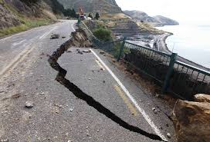
Ideas, we want yours!
If there is somewhere you would like to go or visit please see one of us and we will try and arrange.
Ferrymead
On Wednesday 18th February after lunch (weather permitting), Calvin and I will take up to eight residents to Ferrymead. There we will take a leisurely stroll about and look at all the old bits and pieces of yesteryear ( approximately 2 hour duration). Please see Steve for a place, the first eight to confirm will be going.
The build
Thanks to everyone for putting up with all the noise the tradesman have been making. I'm trying to finish everything as quickly as possible... hopefully we will be green for go in about mid March!
The internal courtyard will have a cottage style theme with a lovely water feature, cottage plants including maple trees in tubs and best of all we will be getting some comfy outdoor seating. If you want to know more come see me and I’ll show you the plans.
Mystery Prize
Whoever can use all the letters from all our residents first and surnames and make some words. First correct answer to Steve wins!
The letters.. JBRREHWMPMODBSRMREMPPOJSKD
If no one can use them all closest by 19th Feb wins!
Comings and Goings
A belated welcome to June who joined us in early November... Time certainly passes quick. Please make her feel at home.

Finally.....
If you have bit and bobs you wish to contribute please see Jenny or I. Steve

